Student Name: Abdul Basit
Student CMS/SAP ID: 70342
Submission Date & Time: 20-03-2026
Course : Electronic Devices and Circuits(EDC)
Department: Department of electrical and Engineering
Instructor: shahid wazir
………………………………………………………………………………………………………………………………………………..
PROJECT REPORT

PROBLEM TITLE :
Analysis of PN Junction Diode V-1 Characteristics and Load line using MATLAB.
Problem statement:
The main objective of this project to analyze the V-I characteristics of PN junction diode. How diode works in forward baised and current voltage exponentially relationship.This project also demonstrate the Q point (Quiesiet line) on the Load line. This project also tells about behaviour of diode on different parameters.
Circuit specification:
The circuit consist a resistor of 1 kilo ohm, voltage source of 10V and a diode is connected in forward baised.All component are connected in series circuit we applied KVl in this circuit.
Circuit:
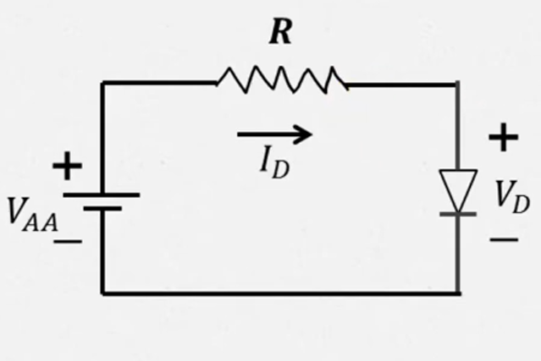
Operation of PN Junction Diode:
In the forward baised , the P side is connected to positive terminal and N side is connected to negative terminal, the depletion region becomes smaller and current passage increased exponentially “knee voltage” approximately upto 0.7V.
In the reverse baised, the P side is connected to negative terminal and the depletion region becomes increased so the little bit smaller current passes.
Shockely Equation:
The non_linear equation is given as:
I = Is (exp(Vd/Vt) - 1).
“I” is the diode current. V is the diode voltage. Vt is the thermal temperature(approx 26mV). n is the ideality factor.
Load Line Analysis:
using KVL the equation becomes
Vs = Vd + IR.
Then further arranging
I = (Vs - Vd)/R
The load line is a straight line with a slope -1/R. Intercepts are (0, Vs/R) and (Vs, 0).
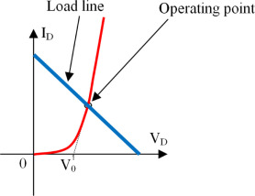
MATLAB Methodology:
First of all, MATLAB is used to define circuit parameters, generate diode V–I characteristics using Shockley.
equation, plot load line, and determine Q-point numerically. Graphs are plotted for visualization.
Code:-
clc
clear
close all

Vs = 10;
R = 1000;
Is = 1e-12;
Vt = 0.026;

Vd = linspace(0,0.8,1000);

Id = Is*(exp(Vd./Vt)-1);

I_load = (Vs - Vd)/R;

figure
plot(Vd,Id,'r','LineWidth',2)
hold on
plot(Vd,I_load,'b','LineWidth',2)

grid on
xlabel('Diode Voltage V_D (V)')
ylabel('Current (A)')
title('Diode V-I Characteristics and Load Line')
legend('Diode Curve','Load Line')

[~,index] = min(abs(Id - I_load));
Vq = Vd(index);
Iq = Id(index);

fprintf('Q-point Voltage = %.3f V\n',Vq)
fprintf('Q-point Current = %.6f A\n',Iq)

rd = Vt/Iq;
fprintf('Dynamic Resistance = %.2f Ohms\n',rd)

Graph:(USE MATLAB SIMULATOR)
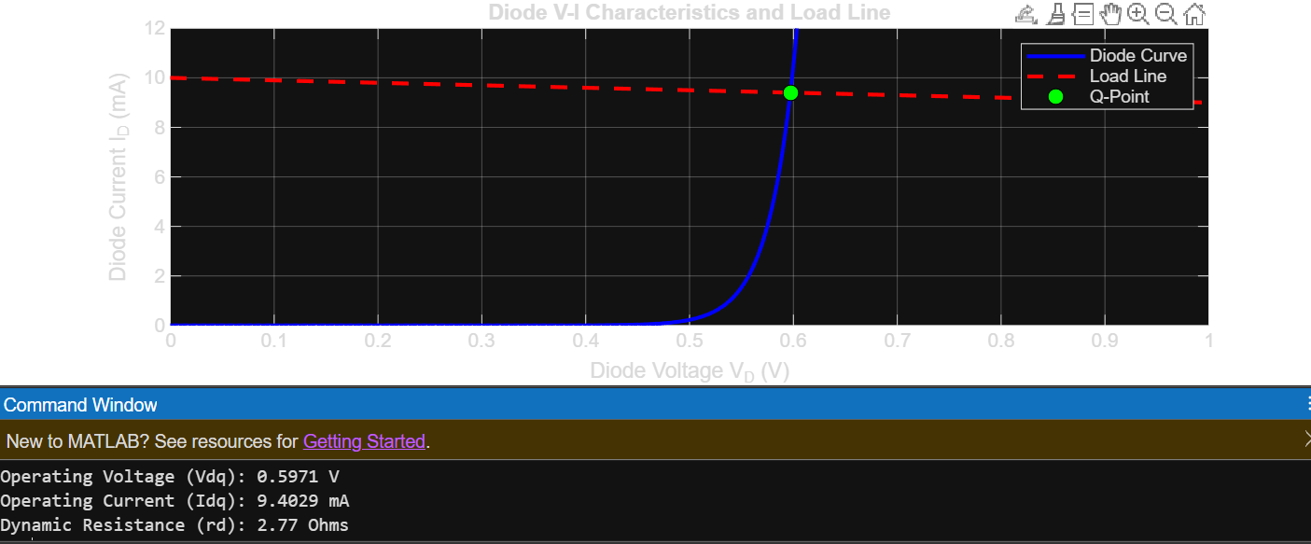
Results:
The Q-point is approximately Vd » 0.6V and Id » 9.4mA. Dynamic resistance rd = Vt/Id » 2.7W.
These values match theoretical expectations.
Analysis:
Observation:
The diode voltage stays near 0.7V even we are applying 10V. This shows the “voltage regulating” nature.
Variations:
The volage and current are directly related to eachother with the increase of current I and diode voltage and resistance r is inversely proportional to both. These variations affect the operating point of the diode
Practical consideration:
Real diodes have internal resistance, temperature dependence, and breakdown effects. These
factors slightly modify the ideal behavior predicted by Shockley equation
Conclusion:
The experiment successfully demonstrates the nonlinear behavior of a PN junction diode. MATLAB
simulation confirms theoretical results and validates the load line method.
References:
"Numerical Analysis of Semiconductor PN Junctions Using MATLAB" published in the Journal of Scientific Research and Reports (2015).
Authored the book "Electronics and Circuit Analysis using MATLAB", which contains dedicated sections on semiconductor physics and PN junction contact potential/junction current.

